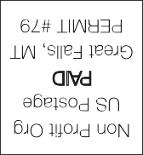
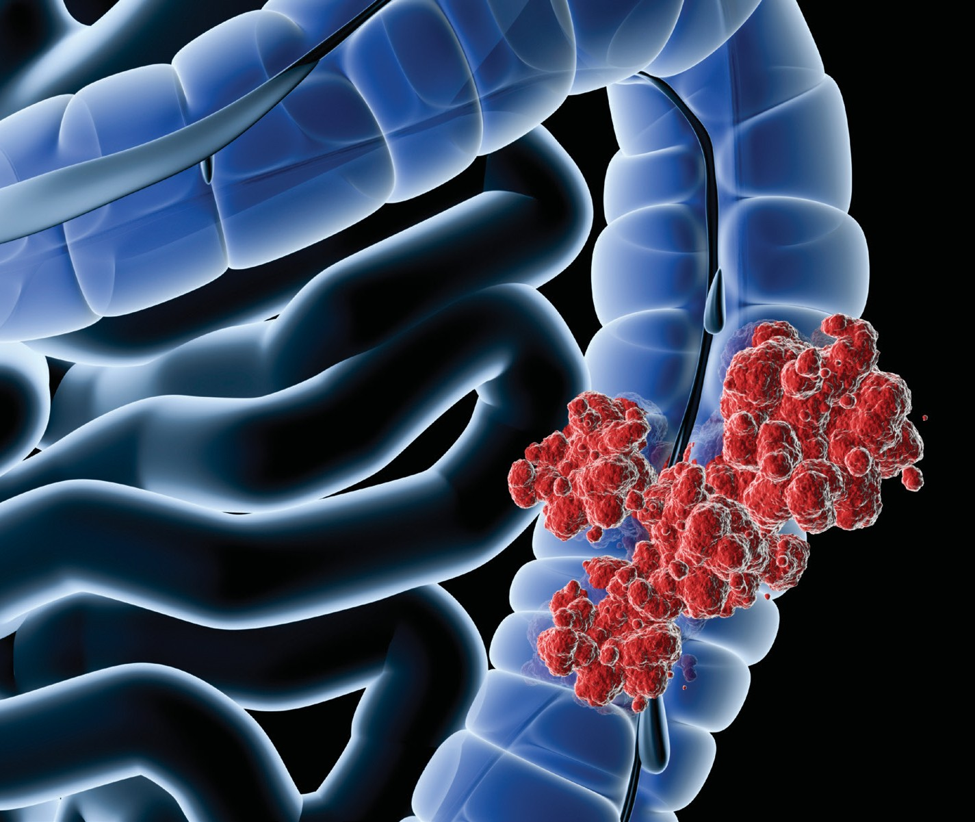

Colorectal Cancer:
A Multidisciplinary Approach to Prevention, Screening, Diagnosis, and Treatment

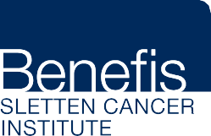
Friday, April 6, 2018 | 8 a.m. - 4:30 p.m. Benefis East Campus | Entrance 2 | Cameron Auditorium 1101 26th Street South, Great Falls, MT 59405
For more information, call (406) 731-8250

PURPOSE

A conference focused on current and evolving technologies in the diagnosis, evaluation, and treatment of colorectal cancer. Interactive lectures and case presentations will be used to provide evidence-based strategies to implement in your practice.
TARGET AUDIENCE
General practice providers, nursing, pharmacists, and all other interested healthcare professionals.
OBJECTIVES
- Discuss the critical role primary care providers play in appropriate screening for colorectal cancer.
- Identify high-risk individuals and refer for appropriate screening.
- Discuss current diagnostic and treatment modalities for colorectal cancer.
- Describe 80% by 2018 initiative.

SCHEDULE
Friday, April 6

7:30 a.m. Registration, Continental Breakfast
8:00 a.m. Welcome and Introduction – Bryan Martin, MD
8:15 a.m. Colorectal Cancer Screening – Thomas Attaway, MD
9:00 a.m. Surgical Approaches to Colorectal Cancer – Glenn Winslow, MD, FACS 9:45 a.m. Break
10:00 a.m Pathology in Colorectal Cancer – Richard C. Carson, MD 10:30 a.m. Update on Hereditary Colon Cancer – Betsy Smith, MS, CGC 11:30 a.m. Lunch
12:15 p.m. Basics in Stoma Care – Rebecca Samson, MSN, FNP-C 12:45 p.m. Nutrition and Colon Cancer – Hannah Cham-A-Koon, MS, RD 1:15 p.m. Obesity and Malignancy – Siddharth Kudav, MD

1:45 p.m. Break
2:00 p.m. Chemotherapy for Colon Cancer – Patrick Tang, MD
2:30 p.m. Indications for Radiation Therapy in Treatment of Colorectal Cancer – Berna DeMalignon, MD
3:00 p.m. Colon and Rectal Cancer – The Future and How to Get There – Grant Harrer, MD, FACP, CPI
3:30 p.m. Case Presentations and Survivorship Issues – Donald Berdeaux, MD; Bryan Martin, MD; Thomas Warr, MD

4:30 p.m. Closing and Evaluation

CONTINUING EDUCATION
Benefis Health System is affiliated with the University of Washington School of Medicine.
The University of Washington School of Medicine is accredited by the Accreditation Council for Continuing Medical Education to provide continuing medical education for physicians.
The University of Washington School of Medicine designates this live activity for a maximum of 7.5 AMA PRA Category 1 Credits™. Physicians should claim only the credit commensurate with the extent of their participation in the activity.
Benefis Health System is an Approved Provider of Continuing Nursing Education by Montana Nurses Association, an accredited approver by the American Nurses Credentialing Center’s Commission on Accreditation.

7.25 contact hours will be provided for this educational activity.

FACULTY

Thomas Attaway, MD
Benefis Gastroenterology
Donald Berdeaux, MD
Benefis Sletten Cancer Institute
Richard C. Carson, MD
Benefis Pathology
Hannah Cham-A-Koon, MS, RD
Benefis Sletten Cancer Institute
Berna DeMalignon, MD
Benefis Sletten Cancer Institute
Grant Harrer, MD, FACP, CPI
Benefis Sletten Cancer Institute
Siddharth Kudav, MD
Great Falls Surgical Associates
Bryan Martin, MD
Benefis Sletten Cancer Institute
Rebecca Samson, MSN, FNP-C
Benefis Hospitalist
Betsy Smith, MS, CGC
Benefis Sletten Cancer Institute
Patrick Tang, MD
Benefis Sletten Cancer Institute
Thomas Warr, MD
Great Falls Clinic Oncology
Glenn Winslow, MD, FACS
Great Falls Surgical Associates

REGISTRATION
Registration is required to attend. Cost is $75.00 ($25.00 for Benefis Health System employees, medical staff,
and volunteers). Fee includes refreshments, lunch, and handouts.

CANCELLATION
A $25.00 processing fee will be deducted from refunds for each cancellation before March 2, 2018. No refunds will be made after March 2, 2018.

REGISTRATION FORM — Colorectal Cancer: A Multidisciplinary Approach to Prevention, Screening, Diagnosis, and Treatment

Name Address

City State ZIP

Payment Options:

Check payable to Benefis
Credit or Debit Card
Name on card: Type of card:

Employee Payroll Deduction
I am an active status employee. I authorize Benefis PayrolI Department to deduct from my paycheck a total of $25.00 for this conference.
Employee Number:

Phone Email
Card number:
Exp. date: Security code: Billing address if different from above:
Name (Print): Signature:

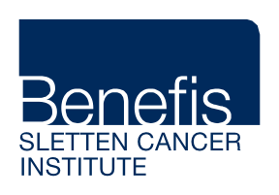Profession:
Physician Registered Nurse
Other

Return a copy of this completed form and payment to:

Benefis Sletten Cancer Institute, 1117 29th Street South, Great Falls, Montana 59405

