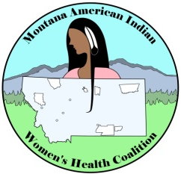
2019 MAIWHC Spring Meeting Agenda
May 7th-8th, 2019

Tuesday, May 7th – 8:00am-8:00pm
8:00am – 4:30pm MTCC- Montana Cancer Coalition statewide meeting
5:30pm – 8:00pm WELCOME – Dinner

Wednesday, May 8th - 7:30 AM-3:45 PM
7:30am – 8:00am Morning Walk- Meet in the Lobby

8:00am – 8:30am Breakfast

8:30am – 8:45am Welcoming and Prayer

8:45am – 9:15am Introductions of all membership
Three Questions Ice Breaker

9:15am – 11:00am 2018 MAIWHC successes:
5-year strategic plan progress and accomplishments
  - Health Disparities among American Indian Communities
    - Heather Zimmerman – MCCP Epidemiologist
MAIWHC member spotlight: Dana Kingfisher and Katelyn Conway
  - Position Overview – What our jobs entail
- SUCCESS STORY: 2018 Blackfeet Reservation Circle of Life Training and Pink Ribbon Bingo

11:00am-11:45am Looking ahead: The Future of MAIWHC

11:45am – 12:00pm Break- Check out of Hotel

12:00pm – 1:00pm Lunch

1:00pm – 2:30pm MAIWHC Project Development and Meeting Planning for Year 4: 2019-2020

2:30pm – 2:40pm MAIWHC Leadership Nominations

2:40pm – 3:15pm MAIWHC member recognition and awards

3:15pm-3:30pm MAIWHC Leadership Elections

3:30pm – 4:00pm Evaluation/Gift exchange

