Caregiver Retreat
Wellness & Self-Compassion for the Healthcare Provider
November 1-3, 2019
Agenda

 | Friday, November 1st | Saturday, November 2nd |  | Sunday, November 3rd
7 a.m. |  | Butte Hike | Yoga | Butte Hike | Yoga
8 a.m. |  | Breakfast |  | Breakfast
9 a.m. |  | Presentation  Dr. Tina Runyan  Mindfulness Practice Module 4- Self-Compassion |  | Presentation  Dr. Tina Runyan  Mindfulness Practice Module 7- Burnout & Resilience
10 a.m.
11 a.m. |  | Presentation  Dr. Tina Runyan  Mindfulness Practice Module 6- Grief & Loss (plus responding to suffering) |  | Breakout Sessions (11-12:30)  - Brain Research- Katherine Schwartz, LCSW  - TBD  - TBD
Noon
1 p.m. |  | Lunch  Round Table Discussions  - Coping with caring during end of life- Dr. Chris Jons  - Advocacy in medicine/ healthcare- Dr. Caitlin Blau  - Recognizing strengths- Katherine Schwartz, LCSW  - Plan for personal resilience- Dr. Christine Lustik |  | Lunch
2 p.m. |  | Breakout Sessions (2-3:30)  - Art Activity- Kate Crouch  - Self-Accupressure- Shawn Robertson  - Healthy Cooking- Chef Joe Colistro |  | Presentation  Dr. Tina Runyan  Mindfulness Practice Module 12- Bringing it home
3 p.m. | Arrival- Check-in/ Registration
4 p.m. |  | Breakout Sessions (4-5:30)  - Mindfulness Practice Module 5- When things go wrong (medical errors)- Dr. Tine Runyan  - Osteopathic manipulation- Dr. Caitlin Blau & Dr. Dan McCarthy  - Butte Hike- Mindfulness in Nature- Dr. Christine Lustik |  | Departure
5 p.m. | Keynote Address 5-6:30 p.m.  Dr. Tina Runyan  Mindfulness Practice Modules 1 & 2- Introduction & Noticing
6 p.m. |  | Dinner & Social Time- 6:30
7 p.m. | Dinner & Social Time  6:30-7:30 p.m. | Entertainment- 7:30  The Misfortune Tellers
8 p.m. | Entertainment- Bits & Pieces
9 p.m. | Screening of “Happy” | Free Time- Hot tub, coffee bar, rec room, art barn  Chair Massages available by appointment
10 p.m. | Free Time- Hot tub, coffee bar, rec room, art barn

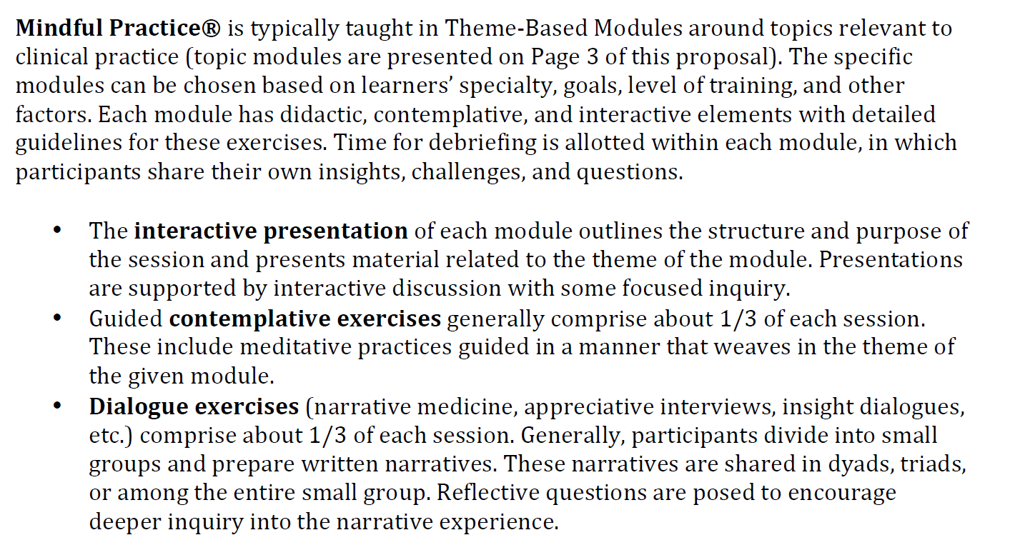
Keynote Speaker-

Tina Runyan, PhD, ABPP
Professor
Department of Family Medicine and Community Health
University of Massachusetts Medical School
________________________________________________________________
Dr. Runyan is a professor in the Department of Family Medicine and Community
Health at the University of Massachusetts Medical School. She is the director of
Behavioral Science for the Worcester Family Medicine Residency Program and the
director of a post-doctoral fellowship in clinical health psychology in primary care.
For 19 years has been practicing, teaching and training behavioral health providers
and physicians in models of interprofessional and collaborative primary care. Dr.
Runyan is a nationally recognized leader in collaborative care and serves as the
immediate Past-President of the Collaborative Family Healthcare Association
(CFHA). She has written and presented extensively about integrated care and is also
involved with developing and implementing education, training, and policies to
promote clinician well-being in medicine. Dr. Runyan also serves as the house
officer counselor for Graduate Medical Education at UMMS, treating resident and
fellow physicians.

Several years ago Dr. Runyan identified an unmet need within the family medicine
residency curriculum to address resident wellness and burnout prevention.
Drawing on her training as a 200-hour registered yoga teacher, her training in
Mindfulness-Based Stress Reduction (MBSR) and Mindfulness Based Cognitive
Therapy (MBCT), and her health psychology roots she developed and implemented
a longitudinal wellness curriculum. She is now leading a departmental initiative for
promoting faculty well-being, helps other departments implement mindfulness in
medicine and well-being initiatives, and runs a year-long mindful physician
leadership course for physicians across Massachusetts.

