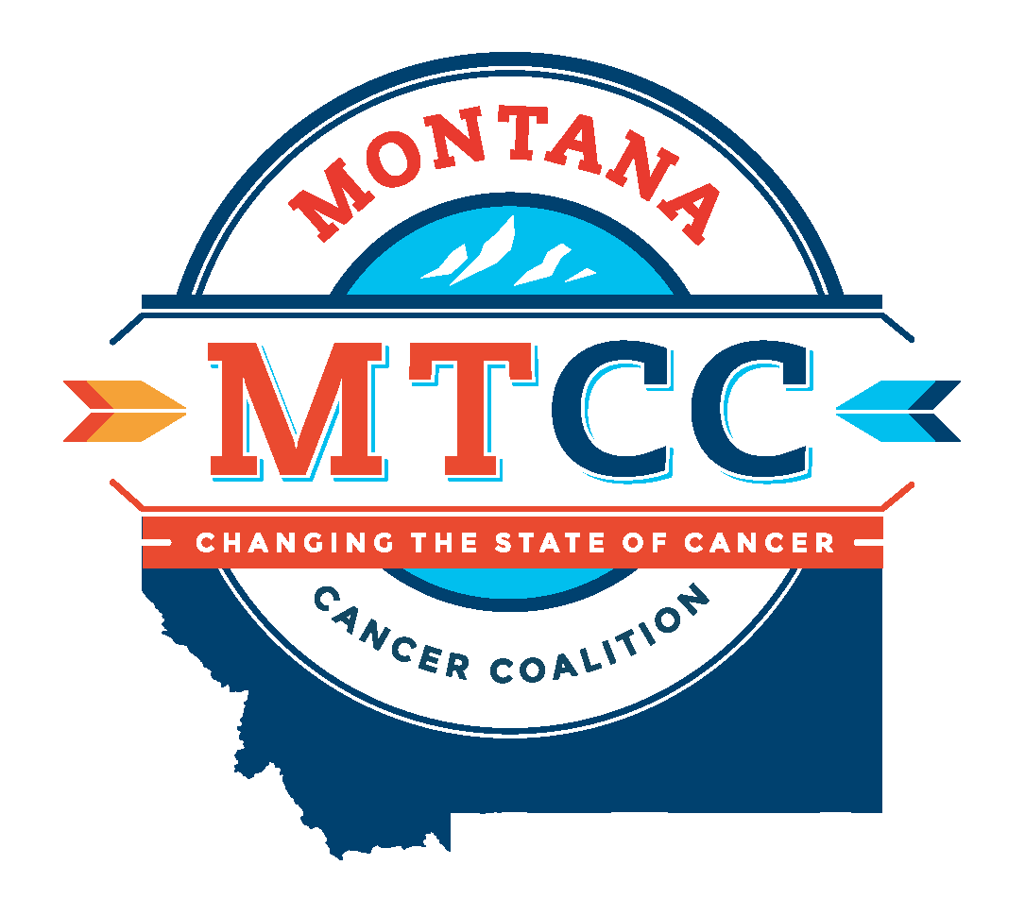
MONTANA COMPREHENSIVE CANCER CONTROL
2016-2021 PLAN GOALS AND OBJECTIVES

Prevention
Goal: Prevent cancer from occurring.
Objectives:
- Reduce the proportion of adolescents who use artificial sources of ultraviolet (UV) light for tanning.
- Increase the number of statewide, regional, and tribal organizations that implement sun safety practices.
- Increase the number of adolescents fully immunized against human papillomavirus.
- Decrease the prevalence of commercial tobacco use and exposure to second hand smoke by working with the Montana Tobacco Use Prevention Program (MTUPP) and other tobacco prevention partners.
- Support the work of the MTUPP to reduce the impact of tobacco use on cancer risk.
- Decrease prevalence of overweight and obese individuals through physical activity, nutrition and health promotion/improvement interventions.

Early Detection
Goal: Detect cancer at its earliest stages.
Objectives:
- Increase screening using nationally recognized guidelines for breast, cervical, colorectal, and lung cancers.
- Increase the number of men who recognize the need for an informed decision-making discussion with their providers regarding prostate cancer screening and treatment.
- Increase the use of hereditary cancer risk assessment through genetic counseling and appropriate genetic testing.

Treatment and Research
Goal: Diagnose and treat all patients using the most effective patient and family-centered care.
Objectives:
- Increase availability of and access to diagnostic and cancer treatment modalities.
- Increase the percentage of cancer patients who are annually accrued to clinical trials.

Quality of Life and Survivorship
Goal: Enhance survivorship and quality of life for every person affected by cancer.
Objectives:
- Increase the number of cancer survivors who receive a comprehensive care summary and follow-up plan after completing treatment.
- Increase the number of cancer patients, families and caregivers who are connected with psychosocial and rehabilitation services.
- Improve availability of palliative care and hospice services.
- Increase the use of advanced care plans.

Pediatric Cancer
Goal: Ensure childhood cancer patients are provided patient-centered treatment and survivorship services that improve quality of life.
Objectives:
- Increase Montana’s capacity to provide continuum of care for youth with cancer, from diagnosis through long-term survivorship.
- Increase education to schools, families, primary care providers, health departments, Indian Health Services and Tribal Health Care on the physical, emotional and cognitive impact of childhood cancer.
- Increase the number of psychosocial support opportunities in Montana for youth and families.

Across the Spectrum of Care
Goal: The Montana Cancer Coalition has an active and diverse membership, dedicated to cancer prevention, early detection, treatment and research, quality of life and survivorship, and pediatric cancer across Montana.
Objectives:
- Improve healthcare and cancer care access for American Indians in Montana, on and off the Reservations, and in Urban Centers.
- Develop and maintain an online Montana Cancer Resource Guide (MTCRG).
- Develop unity in leadership of the coalition; develop a diverse membership that is capable of implementing the objectives of the 2016-2021 Comprehensive Cancer Control (CCC) Plan.

