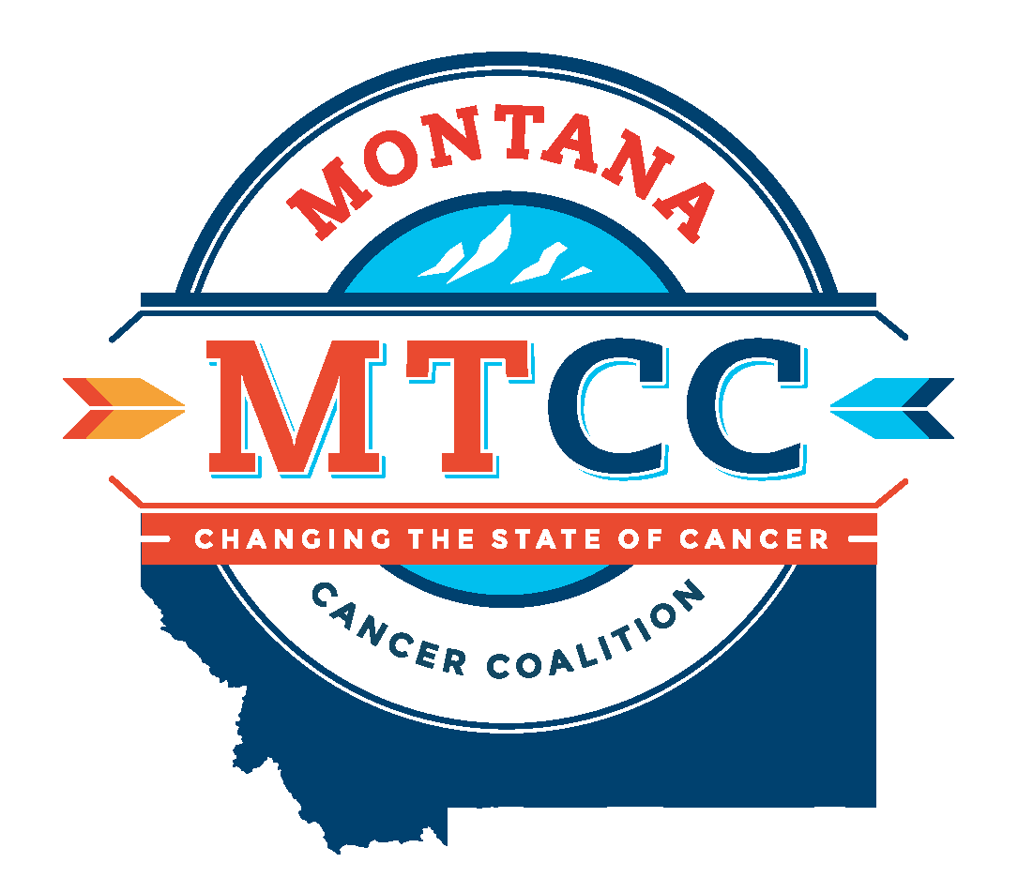
MONTANA COMPREHENSIVE CANCER CONTROL
2022-2026 PLAN GOALS AND OBJECTIVES

Prevention
Goal: Prevent cancer from occurring.
Objectives:
- Reduce the proportion of adolescents who use artificial sources of ultraviolet light for tanning.
- Increase the number of statewide, regional, and tribal organizations that implement sun safety practices.
- Increase the percentage of adolescents fully immunized against human papillomavirus (HPV).
- Support the work of the Montana Tobacco Use Prevention Program (MTUPP) to reduce the impact of tobacco use on cancer risk and decrease the prevalence of commercial tobacco and e-cigarette use and exposure to secondhand smoke.
- Increase access to physical activity, nutrition, and health promotion.

Early Detection
Goal: Detect cancer at its earliest stages.
Objectives:
- Increase screening using nationally recognized guidelines for breast, cervical, colorectal, and lung cancers.
- Increase the use of hereditary cancer risk assessment through genetic counseling and appropriate genetic testing for those whose family histories are associated with an increased risk for genetic mutations.

Access to Care for All
Goal: Ensure all Montanans have access to the most effective patient and family centered cancer care and cancer screening.
Objectives:
- Increase availability of and access to evidence based and best practice resources on diagnostic and cancer treatment modalities.
- Increase access and utilization of telehealth services.
- Improve the health equity of oncology care in Montana by increasing awareness of cultural and linguistic preferences among diverse populations.
- Assess burnout in oncology healthcare workers in Montana.

Quality of Life and Survivorship
Goal: Enhance quality of life during survivorship for every person affected by cancer.
Objectives:
- Increase the number of cancer treatment centers where the oncologist connects the patient with a Primary Care Provider (PCP) to work in partnership from time of diagnosis through long-term survivorship.
- Increase knowledge of available services for psychosocial, palliative care, pain, and physical support as a best practice standard in cancer care delivery.
- Increase access to emotional and physical support services for cancer patients, families, and caregivers across Montana, focusing on rural communities and American Indian Reservations.

Pediatric Cancer
Goal: Ensure childhood cancer patients and families are provided patient-centered treatment and survivorship services that improve quality of life.
Objectives:
- Increase Montana’s capacity to provide a long-term survivorship care for youth with cancer.
- Increase education to schools, families, primary care providers, health departments, Indian Health Service and Tribal Health Care on the physical, emotional, and cognitive impact of childhood cancer on patients and families.
- Increase the number of support services (psychosocial, financial, logistical) available in Montana for youth and families.

